Environmental Policy

Environmental Policy

Kirkwells Ltd believe that we have a responsibility to care for and protect the environment in which we operate. We are fully committed to improving environmental performance across all of our business activities, and will encourage our business partners and members of the wider community to join us in this effort.

Kirkwells Ltd recognises our key impacts to be in the areas of:

- energy use
- raw material use
- waste generation
- emissions to air/water
- water use
- transport
- procurement

We will strive to:

- Adopt the highest environmental standards in all areas of operation, meeting and exceeding all relevant legislative requirements.
- Assess our organisational activities and identify areas where we can minimise impacts.
- Minimise waste through careful and efficient use of all materials and energy.
- Purchase sustainable products wherever feasible [e.g. recycled, FSC or low environmental impact products and energy from renewable sources].
- Publicise our environmental position.
- Train employees in good environmental practice and encourage employee involvement in environmental action.
- Reduce risks from environmental, health or safety hazards for employees and others in the vicinity of our operations.
- Adopt an environmentally sound transport strategy.
- Aim to include environmental and ethical considerations in investment decisions where appropriate.
- Assist in developing solutions to environmental problems.
- Continually assess the environmental impact of all our operations.

Kirkwells Ltd are developing a series of action plans to supplement each of our environmental policy objectives and will periodically review performance and publish these results in an appropriate manner.

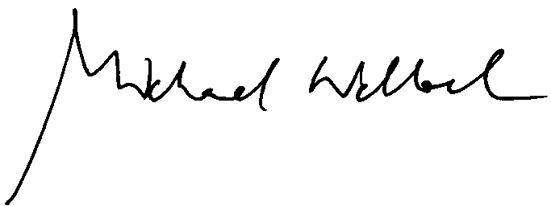

Signed ______Michael Wellock________________ [Director]

